**Network Optimization with Gurobi**

**Task 1**

**Python Code:**

from gurobipy import *   
  
m = Model(**'Project2Task1'**)  
  
nodes = [**'A'**, **'B'**, **'C'**, **'D'**, **'E'**, **'F'**, **'G'**, **'H'**]  
  
*# Capacity-dependent cost is 5 MU per 10 Mbps. Links are 1 Gbps.*cap_dep_cost = 5  
  
*# Setup cost is 100 MU * cost multiplier*setup_cost = 100  
  
demands, dAmount = multidict({  
 (**'A'**, **'B'**): 100,  
 (**'A'**, **'C'**): 100,  
 (**'A'**, **'D'**): 100,  
 (**'A'**, **'E'**): 100,  
 (**'A'**, **'F'**): 100,  
 (**'A'**, **'G'**): 100,  
 (**'A'**, **'H'**): 100})  
demands = tuplelist(demands)  
  
links, cost, install_cost = multidict({  
 (**'A'**, **'B'**): [2*cap_dep_cost, 2*setup_cost],  
 (**'B'**, **'A'**): [2*cap_dep_cost, 2*setup_cost],  
 (**'A'**, **'C'**): [2*cap_dep_cost, 2*setup_cost],  
 (**'C'**, **'A'**): [2*cap_dep_cost, 2*setup_cost],  
 (**'B'**, **'D'**): [2*cap_dep_cost, 2*setup_cost],  
 (**'D'**, **'B'**): [2*cap_dep_cost, 2*setup_cost],  
 (**'D'**, **'F'**): [2*cap_dep_cost, 2*setup_cost],  
 (**'F'**, **'D'**): [2*cap_dep_cost, 2*setup_cost],  
 (**'C'**, **'F'**): [3*cap_dep_cost, 3*setup_cost],  
 (**'F'**, **'C'**): [3*cap_dep_cost, 3*setup_cost],  
 (**'C'**, **'E'**): [2*cap_dep_cost, 2*setup_cost],  
 (**'E'**, **'C'**): [2*cap_dep_cost, 2*setup_cost],  
 (**'E'**, **'G'**): [1*cap_dep_cost, 1*setup_cost],  
 (**'G'**, **'E'**): [1*cap_dep_cost, 1*setup_cost],  
 (**'G'**, **'H'**): [2*cap_dep_cost, 2*setup_cost],  
 (**'H'**, **'G'**): [2*cap_dep_cost, 2*setup_cost],  
 (**'F'**, **'H'**): [1*cap_dep_cost, 1*setup_cost],  
 (**'H'**, **'F'**): [1*cap_dep_cost, 1*setup_cost]  
})  
links = tuplelist(links)  
  
flow = {}  
for i,j in links:  
 for d in demands:  
 flow[i,j,d] = m.addVar(name=**'flow_%s_%s_%s'** % (i, j, d))  
  
capacity = {}  
install = {}  
for i,j in links:  
 capacity[i, j] = m.addVar(name=**'capacity_%s_%s'** % (i, j))  
 install[i,j] = m.addVar(vtype=GRB.INTEGER, name=**'install_%s_%s'** % (i,j))  
  
m.update()  
  
*# Flow balance at source, output, and interior nodes*for i in nodes:  
 for d in demands:  
 if i == d[0]:  
 m.addConstr(  
 quicksum(flow[i,j,d] for i,j in links.select(i,**'*'**)) -  
 quicksum(flow[k,i,d] for k,i in links.select(**'*'**,i))  
 == dAmount[d], **'node_%s_%s'** % (i, d))  
 elif i == d[1]:  
 m.addConstr(  
 quicksum(flow[i, j, d] for i, j in links.select(i, **'*'**)) -  
 quicksum(flow[k, i, d] for k, i in links.select(**'*'**, i))  
 == -dAmount[d], **'node_%s_%s'** % (i, d))  
 else:  
 m.addConstr(  
 quicksum(flow[i, j, d] for i, j in links.select(i, **'*'**)) -  
 quicksum(flow[k, i, d] for k, i in links.select(**'*'**, i))  
 == 0, **'node_%s_%s'** % (i, d))  
  
*# Capacity constraints*for i,j in links:  
 m.addConstr(quicksum(flow[i,j,d] for d in demands) <= capacity[i,j],  
 **'cap_%s_%s'** % (i, j))  
 m.addConstr(capacity[i,j] <= 800*install[i,j],  
 **'install_%s_%s'** % (i, j))m.update()  
  
totalCost = quicksum((capacity[i, j]*cost[i, j] + install[i, j]*install_cost[i, j]) for i, j in links)  
m.setObjective(totalCost, GRB.MINIMIZE)  
m.update()  
  
m.optimize()

**Resultant Graph with Link Capacity:**

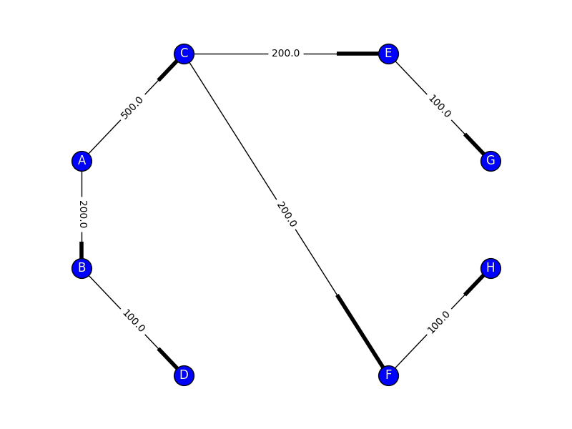

**Resultant Graph with Demand Flow:**

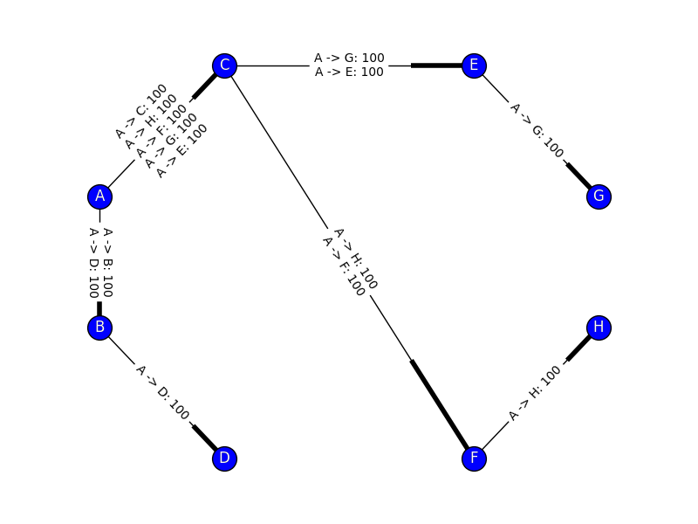

**Total Cost of the Network:** 15300

**Task 2**

**Python Code:**

from gurobipy import *   
  
m = Model(**'Project2Task2'**)  
  
nodes = [**'A'**, **'B'**, **'C'**, **'D'**, **'E'**, **'F'**, **'G'**, **'H'**]  
  
*# Capacity-dependent cost is 5 MU per 10 Mbps. Links are 1 Gbps.*cap_dep_cost = 5  
  
*# Setup cost is 100 MU * cost multiplier*setup_cost = 100  
  
demands, dAmount = multidict({  
 (**'A'**, **'B'**): 100,  
 (**'A'**, **'C'**): 100,  
 (**'H'**, **'D'**): 100,  
 (**'H'**, **'E'**): 100,  
 (**'H'**, **'F'**): 100,  
 (**'H'**, **'G'**): 100})  
demands = tuplelist(demands)  
  
links, cost, install_cost = multidict({  
 (**'A'**, **'B'**): [2*cap_dep_cost, 2*setup_cost],  
 (**'B'**, **'A'**): [2*cap_dep_cost, 2*setup_cost],  
 (**'A'**, **'C'**): [2*cap_dep_cost, 2*setup_cost],  
 (**'C'**, **'A'**): [2*cap_dep_cost, 2*setup_cost],  
 (**'B'**, **'D'**): [2*cap_dep_cost, 2*setup_cost],  
 (**'D'**, **'B'**): [2*cap_dep_cost, 2*setup_cost],  
 (**'D'**, **'F'**): [2*cap_dep_cost, 2*setup_cost],  
 (**'F'**, **'D'**): [2*cap_dep_cost, 2*setup_cost],  
 (**'C'**, **'F'**): [3*cap_dep_cost, 3*setup_cost],  
 (**'F'**, **'C'**): [3*cap_dep_cost, 3*setup_cost],  
 (**'C'**, **'E'**): [2*cap_dep_cost, 2*setup_cost],  
 (**'E'**, **'C'**): [2*cap_dep_cost, 2*setup_cost],  
 (**'E'**, **'G'**): [1*cap_dep_cost, 1*setup_cost],  
 (**'G'**, **'E'**): [1*cap_dep_cost, 1*setup_cost],  
 (**'G'**, **'H'**): [2*cap_dep_cost, 2*setup_cost],  
 (**'H'**, **'G'**): [2*cap_dep_cost, 2*setup_cost],  
 (**'F'**, **'H'**): [1*cap_dep_cost, 1*setup_cost],  
 (**'H'**, **'F'**): [1*cap_dep_cost, 1*setup_cost]  
})  
links = tuplelist(links)  
  
flow = {}  
for i,j in links:  
 for d in demands:  
 flow[i,j,d] = m.addVar(name=**'flow_%s_%s_%s'** % (i, j, d))  
  
capacity = {}  
install = {}  
for i,j in links:  
 capacity[i, j] = m.addVar(name=**'capacity_%s_%s'** % (i, j))  
 install[i,j] = m.addVar(vtype=GRB.INTEGER, name=**'install_%s_%s'** % (i,j))  
  
m.update()  
  
*# Flow balance at source, output, and interior nodes*for i in nodes:  
 for d in demands:  
 if i == d[0]:  
 m.addConstr(  
 quicksum(flow[i,j,d] for i,j in links.select(i,**'*'**)) -  
 quicksum(flow[k,i,d] for k,i in links.select(**'*'**,i))  
 == dAmount[d], **'node_%s_%s'** % (i, d))  
 elif i == d[1]:  
 m.addConstr(  
 quicksum(flow[i, j, d] for i, j in links.select(i, **'*'**)) -  
 quicksum(flow[k, i, d] for k, i in links.select(**'*'**, i))  
 == -dAmount[d], **'node_%s_%s'** % (i, d))  
 else:  
 m.addConstr(  
 quicksum(flow[i, j, d] for i, j in links.select(i, **'*'**)) -  
 quicksum(flow[k, i, d] for k, i in links.select(**'*'**, i))  
 == 0, **'node_%s_%s'** % (i, d))  
  
*# Capacity constraints*for i,j in links:  
 m.addConstr(quicksum(flow[i,j,d] for d in demands) <= capacity[i,j],  
 **'cap_%s_%s'** % (i, j))  
 m.addConstr(capacity[i,j] <= 2000*install[i,j],  
 **'install_%s_%s'** % (i, j))  
  
m.update()  
  
totalCost = quicksum((capacity[i, j]*cost[i, j] + install[i, j]*install_cost[i, j]) for i, j in links)  
m.setObjective(totalCost, GRB.MINIMIZE)  
m.update()  
  
m.optimize()

**Resultant Graph with Link Capacity/Demand Flow:**

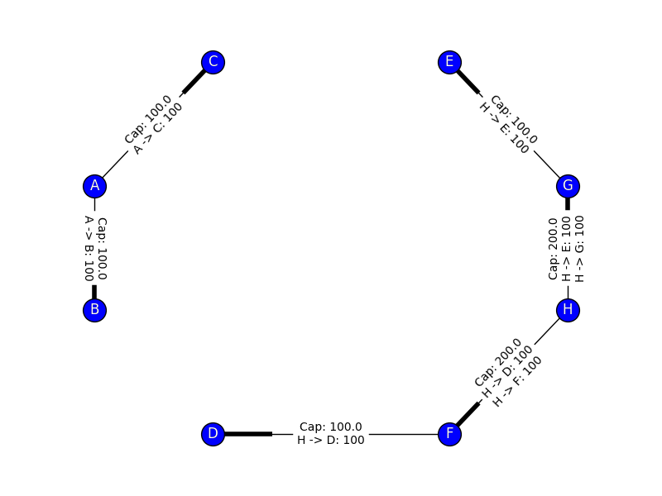

**Total Cost of the Network:** 7500

**Task 3**

**Task 3.1**

**Python Code:**

from gurobipy import *   
  
m = Model(**'Project2Task3-1'**)  
  
nodes = [**'A'**, **'B'**, **'C'**, **'D'**, **'E'**, **'F'**, **'G'**, **'H'**]  
  
*# Capacity-dependent cost is 5 MU per 10 Mbps. Links are 1 Gbps.*cap_dep_cost = 5  
  
*# Setup cost is 100 MU * cost multiplier*setup_cost = 100  
  
DemandNode, DemandSink, DemandSource = multidict({  
 (**'A'**): [0, 700],  
 (**'B'**): [100, 0],  
 (**'C'**): [100, 0],  
 (**'D'**): [100, 0],  
 (**'E'**): [100, 0],  
 (**'F'**): [100, 0],  
 (**'G'**): [100, 0],  
 (**'H'**): [100, 0]  
})  
  
links, cost, install_cost = multidict({  
 (**'A'**, **'B'**): [2*cap_dep_cost, 2*setup_cost],  
 (**'B'**, **'A'**): [2*cap_dep_cost, 2*setup_cost],  
 (**'A'**, **'C'**): [2*cap_dep_cost, 2*setup_cost],  
 (**'C'**, **'A'**): [2*cap_dep_cost, 2*setup_cost],  
 (**'B'**, **'D'**): [2*cap_dep_cost, 2*setup_cost],  
 (**'D'**, **'B'**): [2*cap_dep_cost, 2*setup_cost],  
 (**'D'**, **'F'**): [2*cap_dep_cost, 2*setup_cost],  
 (**'F'**, **'D'**): [2*cap_dep_cost, 2*setup_cost],  
 (**'C'**, **'F'**): [3*cap_dep_cost, 3*setup_cost],  
 (**'F'**, **'C'**): [3*cap_dep_cost, 3*setup_cost],  
 (**'C'**, **'E'**): [2*cap_dep_cost, 2*setup_cost],  
 (**'E'**, **'C'**): [2*cap_dep_cost, 2*setup_cost],  
 (**'E'**, **'G'**): [1*cap_dep_cost, 1*setup_cost],  
 (**'G'**, **'E'**): [1*cap_dep_cost, 1*setup_cost],  
 (**'G'**, **'H'**): [2*cap_dep_cost, 2*setup_cost],  
 (**'H'**, **'G'**): [2*cap_dep_cost, 2*setup_cost],  
 (**'F'**, **'H'**): [1*cap_dep_cost, 1*setup_cost],  
 (**'H'**, **'F'**): [1*cap_dep_cost, 1*setup_cost]  
})  
links = tuplelist(links)  
  
*# G = nx.read_gml('task3.gml')*flow = {}  
for i,j in links:  
*# for i,j in nx.edges(G):* flow[i,j] = m.addVar(name=**'flow_%s_%s'** % (i, j))  
  
capacity = {}  
install = {}  
for i,j in links:  
 capacity[i, j] = m.addVar(name=**'capacity_%s_%s'** % (i, j))  
 install[i, j] = m.addVar(vtype=GRB.INTEGER, name=**'install_%s_%s'** % (i, j))  
  
m.update()  
  
*# Flow balance at source, output, and interior nodes*for i in nodes:  
 m.addConstr(  
 quicksum(flow[i,j] for i,j in links.select(i,**'*'**)) -  
 quicksum(flow[k,i] for k,i in links.select(**'*'**,i))  
 == DemandSource[i] - DemandSink[i], **'node_%s'** % (i))  
  
*# Capacity constraints*for i,j in links:  
 m.addConstr(flow[i,j] <= capacity[i,j],  
 **'cap_%s_%s'** % (i, j))  
 m.addConstr(capacity[i,j] <= 2000*install[i,j],  
 **'install_%s_%s'** % (i, j))  
  
m.update()  
  
totalCost = quicksum((capacity[i, j]*cost[i, j] + install[i, j]*install_cost[i, j]) for i, j in links)  
m.setObjective(totalCost, GRB.MINIMIZE)  
m.update()  
  
m.optimize()

**Task 3.2**

**Python Code:**

from gurobipy import *   
  
m = Model(**'Project2Task3-2'**)  
  
nodes = [**'A'**, **'B'**, **'C'**, **'D'**, **'E'**, **'F'**, **'G'**, **'H'**]  
  
*# Capacity-dependent cost is 5 MU per 10 Mbps. Links are 1 Gbps.*cap_dep_cost = 5  
  
*# Setup cost is 100 MU * cost multiplier*setup_cost = 100  
  
DemandNode, DemandSink = multidict({  
 (**'A'**): 0,  
 (**'B'**): 100,  
 (**'C'**): 100,  
 (**'D'**): 100,  
 (**'E'**): 100,  
 (**'F'**): 100,  
 (**'G'**): 100,  
 (**'H'**): 100  
})  
  
links, cost, install_cost = multidict({  
 (**'A'**, **'B'**): [2*cap_dep_cost, 2*setup_cost],  
 (**'B'**, **'A'**): [2*cap_dep_cost, 2*setup_cost],  
 (**'A'**, **'C'**): [2*cap_dep_cost, 2*setup_cost],  
 (**'C'**, **'A'**): [2*cap_dep_cost, 2*setup_cost],  
 (**'B'**, **'D'**): [2*cap_dep_cost, 2*setup_cost],  
 (**'D'**, **'B'**): [2*cap_dep_cost, 2*setup_cost],  
 (**'D'**, **'F'**): [2*cap_dep_cost, 2*setup_cost],  
 (**'F'**, **'D'**): [2*cap_dep_cost, 2*setup_cost],  
 (**'C'**, **'F'**): [3*cap_dep_cost, 3*setup_cost],  
 (**'F'**, **'C'**): [3*cap_dep_cost, 3*setup_cost],  
 (**'C'**, **'E'**): [2*cap_dep_cost, 2*setup_cost],  
 (**'E'**, **'C'**): [2*cap_dep_cost, 2*setup_cost],  
 (**'E'**, **'G'**): [1*cap_dep_cost, 1*setup_cost],  
 (**'G'**, **'E'**): [1*cap_dep_cost, 1*setup_cost],  
 (**'G'**, **'H'**): [2*cap_dep_cost, 2*setup_cost],  
 (**'H'**, **'G'**): [2*cap_dep_cost, 2*setup_cost],  
 (**'F'**, **'H'**): [1*cap_dep_cost, 1*setup_cost],  
 (**'H'**, **'F'**): [1*cap_dep_cost, 1*setup_cost]  
})  
links = tuplelist(links)  
  
flow = {}  
for i,j in links:  
 flow[i,j] = m.addVar(name=**'flow_%s_%s'** % (i, j))  
  
capacity = {}  
install = {}  
for i,j in links:  
 capacity[i, j] = m.addVar(name=**'capacity_%s_%s'** % (i, j))  
 install[i, j] = m.addVar(vtype=GRB.INTEGER, name=**'install_%s_%s'** % (i, j))  
  
DemandSource = {}  
for i in nodes:  
 DemandSource[i] = m.addVar(name=**'demand-source_%s'** % i)  
  
m.update()  
  
*# Flow balance at source, output, and interior nodes*for i in nodes:  
 m.addConstr(  
 quicksum(flow[i,j] for i,j in links.select(i,**'*'**)) -  
 quicksum(flow[k,i] for k,i in links.select(**'*'**,i))  
 == DemandSource[i] - DemandSink[i], **'node_%s'** % (i))  
  
*# Capacity constraints*for i,j in links:  
 m.addConstr(flow[i,j] <= capacity[i,j],  
 **'cap_%s_%s'** % (i, j))  
 m.addConstr(capacity[i,j] <= 2000*install[i,j],  
 **'install_%s_%s'** % (i, j))  
  
m.update()  
  
totalCost = quicksum((capacity[i, j]*cost[i, j] + install[i, j]*install_cost[i, j]) for i, j in links)  
m.setObjective(totalCost, GRB.MINIMIZE)  
m.update()  
  
m.optimize()

**Why is the total cost zero?** In this example, the optimizer will place a server in each of the nodes, which means that there is no demand to send out over links as requests are processed in the same node. In a graph with no links, there is no cost.

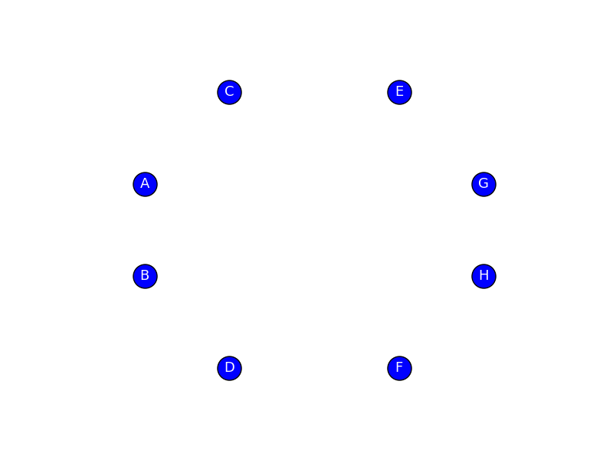

**Task 3.3**

**Python Code:**

from gurobipy import *   
  
m = Model(**'Project2Task3-3'**)  
  
nodes = [**'A'**, **'B'**, **'C'**, **'D'**, **'E'**, **'F'**, **'G'**, **'H'**]  
  
*# Capacity-dependent cost is 5 MU per 10 Mbps. Links are 1 Gbps.*cap_dep_cost = 5  
  
*# Setup cost is 100 MU * cost multiplier*setup_cost = 100  
  
DemandNode, DemandSink = multidict({  
 (**'A'**): 0,  
 (**'B'**): 100,  
 (**'C'**): 100,  
 (**'D'**): 100,  
 (**'E'**): 100,  
 (**'F'**): 100,  
 (**'G'**): 100,  
 (**'H'**): 100  
})  
  
links, cost, install_cost = multidict({  
 (**'A'**, **'B'**): [2*cap_dep_cost, 2*setup_cost],  
 (**'B'**, **'A'**): [2*cap_dep_cost, 2*setup_cost],  
 (**'A'**, **'C'**): [2*cap_dep_cost, 2*setup_cost],  
 (**'C'**, **'A'**): [2*cap_dep_cost, 2*setup_cost],  
 (**'B'**, **'D'**): [2*cap_dep_cost, 2*setup_cost],  
 (**'D'**, **'B'**): [2*cap_dep_cost, 2*setup_cost],  
 (**'D'**, **'F'**): [2*cap_dep_cost, 2*setup_cost],  
 (**'F'**, **'D'**): [2*cap_dep_cost, 2*setup_cost],  
 (**'C'**, **'F'**): [3*cap_dep_cost, 3*setup_cost],  
 (**'F'**, **'C'**): [3*cap_dep_cost, 3*setup_cost],  
 (**'C'**, **'E'**): [2*cap_dep_cost, 2*setup_cost],  
 (**'E'**, **'C'**): [2*cap_dep_cost, 2*setup_cost],  
 (**'E'**, **'G'**): [1*cap_dep_cost, 1*setup_cost],  
 (**'G'**, **'E'**): [1*cap_dep_cost, 1*setup_cost],  
 (**'G'**, **'H'**): [2*cap_dep_cost, 2*setup_cost],  
 (**'H'**, **'G'**): [2*cap_dep_cost, 2*setup_cost],  
 (**'F'**, **'H'**): [1*cap_dep_cost, 1*setup_cost],  
 (**'H'**, **'F'**): [1*cap_dep_cost, 1*setup_cost]  
})  
links = tuplelist(links)  
  
flow = {}  
for i,j in links:  
 flow[i,j] = m.addVar(name=**'flow_%s_%s'** % (i, j))  
  
capacity = {}  
install = {}  
for i,j in links:  
 capacity[i, j] = m.addVar(name=**'capacity_%s_%s'** % (i, j))  
 install[i, j] = m.addVar(vtype=GRB.INTEGER, name=**'install_%s_%s'** % (i, j))  
  
DemandSource = {}  
for i in nodes:  
 DemandSource[i] = m.addVar(name=**'demand-source_%s'** % i)  
  
server_install = {}  
for i in nodes:  
 server_install[i] = m.addVar(vtype=GRB.INTEGER, name=**'server-install_%s'** % i)  
  
m.update()  
  
*# Flow balance at source, output, and interior nodes*for i in nodes:  
 m.addConstr(  
 quicksum(flow[i,j] for i,j in links.select(i,**'*'**)) -  
 quicksum(flow[k,i] for k,i in links.select(**'*'**,i))  
 == DemandSource[i] - DemandSink[i], **'node_%s'** % (i))  
  
*# Capacity constraints*for i,j in links:  
 m.addConstr(flow[i,j] <= capacity[i,j],  
 **'cap_%s_%s'** % (i, j))  
 m.addConstr(capacity[i,j] <= 2000*install[i,j],  
 **'install_%s_%s'** % (i, j))  
  
for i in nodes:  
 m.addConstr(DemandSource[i] <= 2000 * server_install[i],  
 **'server-install-max_%s'** % (i))  
  
m.update()  
  
server_cost = 1000  
  
totalCost = quicksum((capacity[i, j]*cost[i, j] + install[i, j]*install_cost[i, j]) for i, j in links) + quicksum(server_install[i]*server_cost for i in nodes)  
m.setObjective(totalCost, GRB.MINIMIZE)  
m.update()  
  
m.optimize()

For the following, blue represent nodes with servers installed, whereas red nodes do not have servers.

$C_{s}=1000$**Graph:**

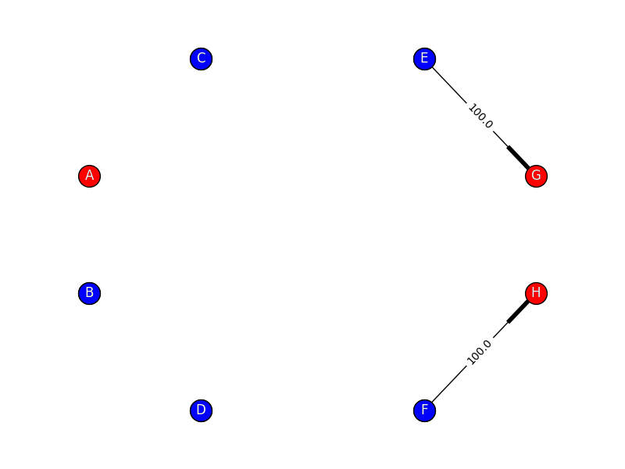

**Total Cost of the Network:** 6200

$C_{s}=3000$**Graph:**

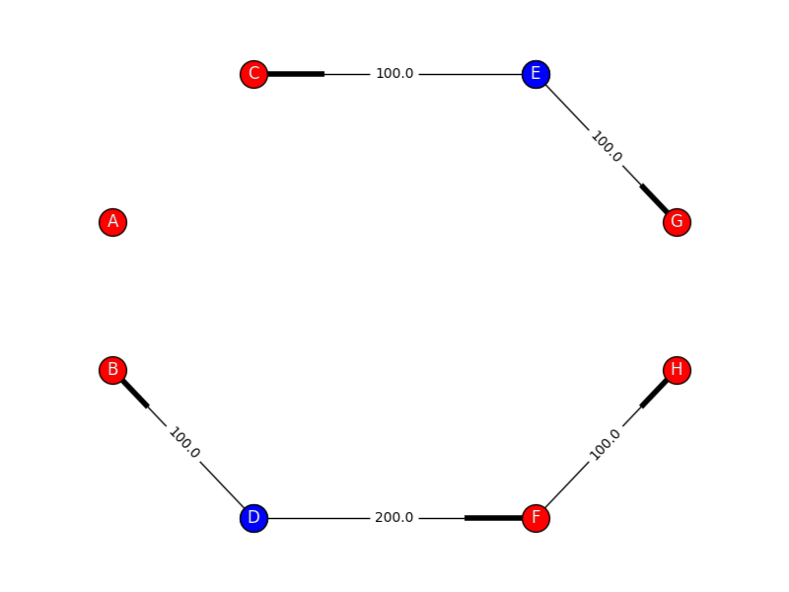

**Total Cost of the Network:** 11800

$C_{s}=5000$**Graph:**

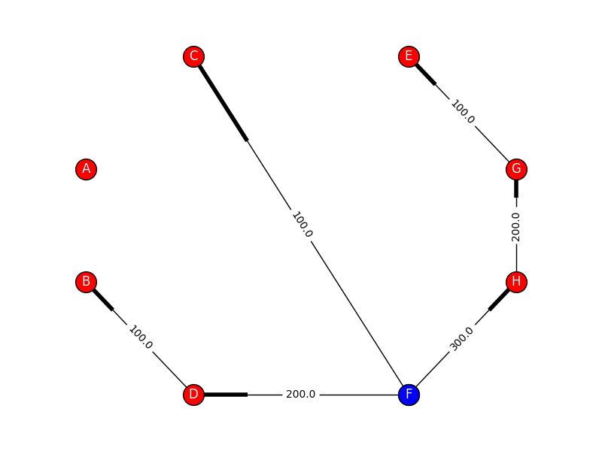

**Total Cost of the Network:** 14600

**Brief Discussion of Server Cost:**

While servers are inexpensive ($C_{s}=1000$) the network operates cheaper with more servers than links, except for in the case where the cost multiplier of the link is 1 – between F and H, E and G. While this cost rises, the number of servers decreases and links are restored, as it is cheaper to maintain the links compared to installing new servers.